IQAC- SATYA INSTITUTE &TECHNOLOGY AND MANGEMENT
Qualitative Metrics
Criteria2: Teaching-Learning and Evaluation
Key Indicator 2.2: Catering to student Diversity

2.2.1 | The Institution assesses the learning levels of the students after admission and organizes special programs for advanced learners and slow learners.
SITAM recognizes and respects the diversity of the student community at admission and all through academic career. It is obvious that students from far-flung areas, with different types of schooling, different aptitudes, different levels of mathematical background, and different levels of analytical aptitude join engineering courses with the ambition of attaining suitable outcomes and seeking professional career.
Careful screening and polarization is needed to segregate students and provide customized content to the maximum possible extent. At SITAM, we assess the level of prerequisite attainment through a series of online quizzes to identify students falling into bottom FOUR levels of Bloom’s Taxonomy Pyramid shown in Figure1.
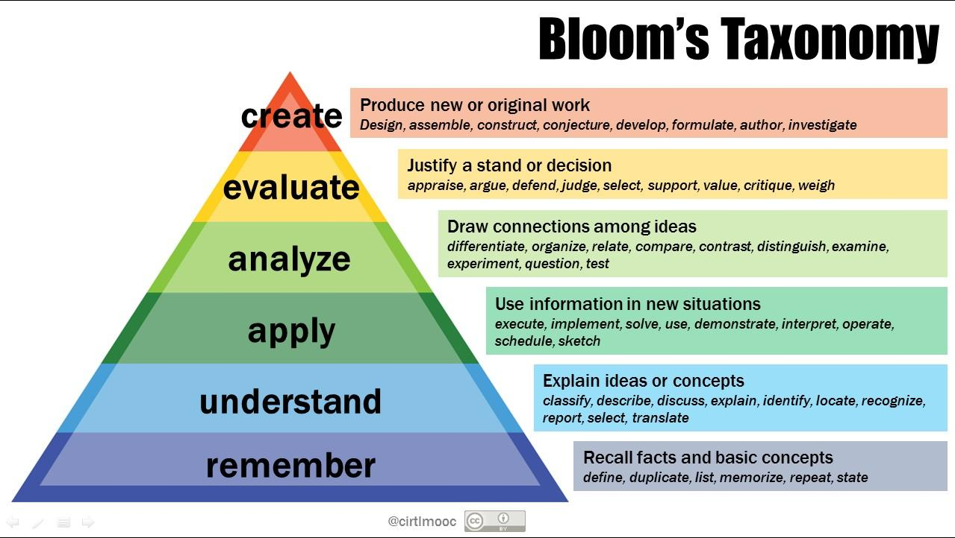
Figure 1 Bloom's Taxonomy
Such a study forms an essential step in understanding the student’s ability to study topics in Mathematics, Drawing, Concepts of Physics, and Engineering fundamentals.
With clear understanding of the student’s capabilities, challenging assignments are designed for groups of students in “advanced” stages and higher rungs Bloom’s Taxonomy. Similarly appropriate reinforcement programs and relatively “easier” assignments are planned for students in lower rungs of Bloom’s Pyramid.
The quizzes and other tools of assessment for polarising are chosen carefully and students are sensitized to be honest far their own sake. The “measuring” forms are chosen to be online as for as possible to let the students attempt them in the comfort and privacy location of his choice.
The tools for assessment are chosen carefully to avoid two situations:
- False positives are instances where the students’ scores high on the assessment tests but the actual “long” range calibre is an lower rungs of Bloom’s Taxonomy.
- False negatives are instances where the student scores very less on the tests but the actual “long” range caliber is an higher rungs of Bloom’s Taxonomy.
During COVID-19 pandemic lock down situations we conducted online classes, online quizzes and assignments to assess the learning levels of the students through ulektz LMS (Learning Managenent System).

